# South Dakota

# Small Community

# Transportation Planning Program

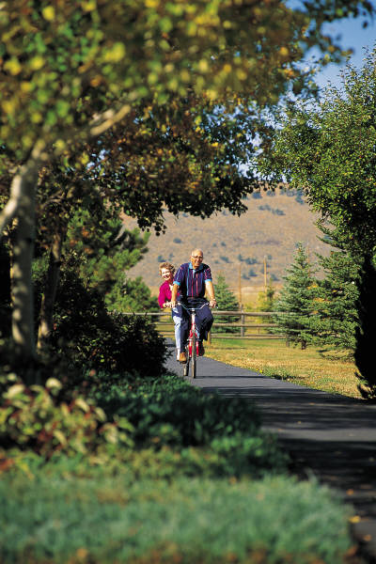  

# Program Summary and Application

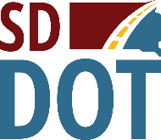

# Small Community Transportation Planning Program

## Overview

The current Federal Infrastructure Investment and Jobs Act (IIJA), continues the requirement that the South Dakota Department of Transportation (SDDOT) set aside 2 percent of the apportionments received from the four federal transportation funding programs (the National Highway Performance Program (NHPP); the Surface Transportation Program (STP); the Highway Safety Improvement Program (HSIP); and the Congestion Mitigation Air Quality Improvement Program (CMAQ)) for transportation planning and research activities. This set-aside program is titled the State Planning & Research (SPR) Program. Historically, the SDDOT used a portion of the SPR funds for transportation planning studies for counties and cities >2000 in population not within a Metropolitan Planning Area (MPO).

The previous federal highway bill (MAP-21) created the Transportation Alternatives Program (TAP), a grant program that uses federal transportation funds for specific activities that enhance the intermodal transportation system and provide safe alternative transportation options. TAP replaced the former Transportation Enhancement Program and consolidated those eligible activities with the Safe Routes to School, Scenic Byways, and Recreation Trails Programs. TAP builds upon the legacy of the Transportation Enhancement Program by expanding travel choices, strengthening the local economy, improving the quality of life, and protecting the environment.

Many small communities applying for grant funds lack comprehensive transportation plans, which could impede obtaining transportation funds and expanding effective networks as the communities grow. Crafting community transportation plans would not only improve grant funding prospects but also promote accessible transportation to schools, businesses, homes, industries, and attractions.

With that in mind, the SDDOT dedicated a portion of its 2020-21 SPR funds to establish the Small Community Transportation Planning Program.

Questions concerning this program should be directed to:

Katrina Burckhard

SDDOT Project Development

700 East Broadway Avenue

Pierre, SD 57501

[Katrina.burckhard@state.sd.us](mailto:Katrina.burckhard@state.sd.us)

Phone 605.773.6641

## Eligibility

All South Dakota communities under 2,000 in population and not included within a Metropolitan Planning Area can apply to have a plan developed under this program.

All cities under 2000 in population not within a Metropolitan Planning Area can also apply for similar funds under the SPR for Local Governments program. Cities and counties within a Metropolitan Planning Area should have their plan developed through that Metropolitan Planning Organization (MPO).

## Funding

The 2020-21 SPR funds will be used for DOT staff time and materials to complete the Small Community Transportation Plan for the selected community or communities. As local match, the selected community will contribute City Staff and City Engineering time and materials. If the City Engineer is a consultant, the City will pay the consultant directly for their time and materials. The selected community will also be responsible for providing the meeting rooms, advertising, and other expenses associated with the community meetings.

## Application

Interested communities must complete the attached application explaining the community’s need for a transportation plan and the desired outcome for the community. Applications should be mailed to Katrina Burckhard, Project Development Office, SDDOT, 700 E. Broadway, Pierre, SD 57501, and must be postmarked on or before March 31st, 2024.

## Plan Development

Upon approval of the application, the SDDOT will work with the local community to establish a community stakeholder team to outline and guide the planning process. The stakeholder team will be comprised of City and school staff, business and industry representatives, interested citizens, and other community members.

The SDDOT will lead the planning process with active participation from the community and community stakeholder team. The study will follow all applicable Federal and State requirements.

City staff will be tasked with gathering existing community information including such items as existing planning documents, relative ordinances and design guidelines, base maps, and other documents to assist with the planning process.

Community involvement in the planning process will include community information gathering, community stakeholder interviews, community input meeting, a community tour, and a community open house to present the final plan.

## Product

The final product produced by the SDDOT with community input may include some or all of the following:

* Community Intermodal (car/truck/bike/walk/train/transit) Transportation Plan
* Safety Elements
* Traffic Calming and Speed Reduction Techniques
* Pavement Management
* Americans with Disabilities Act (ADA) of 1990 Compliance Plan
* Route Designation (Safe Route to School/Safe Route for Non-Drivers/Truck Route)
* Project Identification and Prioritization
* Identification of Funding Sources
* Recommendations of Non-Infrastructure Elements (Education, Enforcement, Encouragement)

## Ineligible Activities

Federal law prohibits the following activities from using SPR funds:

* Preliminary Design
* Final Design
* Construction
* Maintenance
* Equipment Purchase

## Estimated Project Schedule

* **March 31st, 2024** – Application to be submitted to the SDDOT. Applications must be emailed or postmarked on or before March 31st, 2024.
* **Early April, 2024** – Community Selection
* **Late April / Early May, 2024** – Plan kick-off meeting with Selected Communities
* **Late May, 2024** – Community Tour and Input Meetings
* **June and July, 2024**– Plan Development and Educational Sessions
* **August 2024** – Final Plan Presentation

# Recently Completed Studies Under this Program

## Faulkton Area Master Transportation Plan – 2014

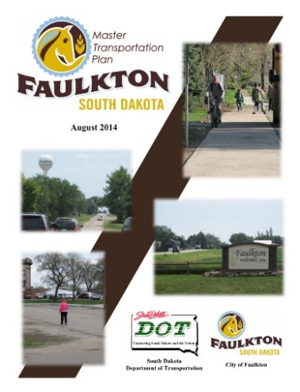 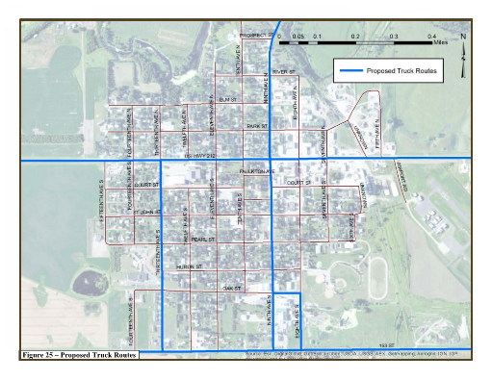

Reference: Sallie Traver, Finance Officer, City of Faulkton, (605) 598-6515.

Study Report: <https://dot.sd.gov/media/documents/FaulktonMasterTransportationPlanWEB.pdf>

## Gregory Area Master Transportation Plan – 2015

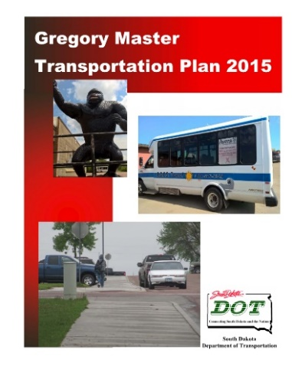 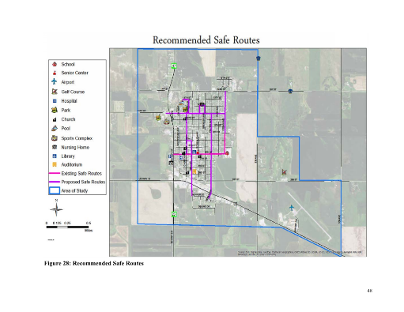

Reference: Al Cerny, City Administrator, City of Gregory, (605) 835-8270.

Study Report: <https://dot.sd.gov/media/documents/Gregory_Master_Transportation_Plan_Final_Report.pdf>

## Wall Area Master Transportation Plan – 2017

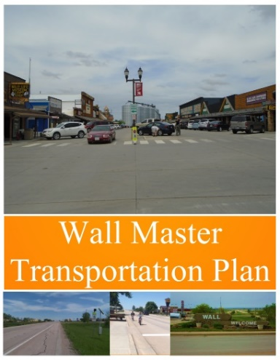 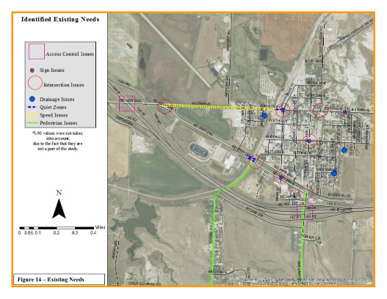

Reference: Cheyenne McGriff, Economic Development Director, City of Wall, (605) 279-2658.

Study Report: <https://dot.sd.gov/media/documents/WallMasterPlan-Final.pdf>

## Hill City Master Transportation Plan – 2023

|  |  |
| --- | --- |
|  |  |

Reference: Brett McMacke, City Administrator, City of Hill City, (605) 574-4327

Study Report: <https://dot.sd.gov/media/HillCity_MTP_Final_wCover.pdf>

# APPLICATION FOR A SMALL COMMUNITY

# TRANSPORTATION PLANNING STUDY

APPLICANT:

## LOCAL STUDY CONTACT

This contact should be knowledgeable about the study’s intentions and the application, as they may be contacted for additional information and will receive all correspondence.

Contact Person:

Title:

Address:

City:       SD

Zip Code:

Phone Number:

Email Address:

## APPROVAL TO SUBMIT APPLICATION

Name:

Signature:

Date:

Please submit on or before March 31st, 2024

to

Katrina Burckhard

SDDOT – Project Development

700 East Broadway Avenue

Pierre, SD 57501

[katrina.burckhard@state.sd.us](mailto:nancy.surprenant@state.sd.us)

Phone: (605) 773-6641

## PLAN INTENTION

Please describe the perceived need for the study and the desired outcome and products the plan will produce for your community and the benefit to your community and, if applicable, the SDDOT.

|  |
| --- |
|  |
|  |
|  |
|  |
|  |
|  |
|  |
|  |
|  |
|  |
|  |
|  |
|  |
|  |
|  |
|  |
|  |

## PUBLIC INVOLVEMENT

Please check all levels of public involvement your community is willing to participate in:

Community Input Meetings/Open House (Required)

Educational Sessions with SDDOT Staff

Citizen member(s) on stakeholder team

City Staff/Official Meetings

Community Tour

## AVAILABLE LOCAL FUNDING

Please list the maximum amount of local funding that will be available to complete this plan (City Engineering expenses, meeting space, meeting advertising, etc.).

$

## AVAILABLE RESOURCES

Are there previous study reports, plans, base map information, photographs, guidelines, or other items available for the SDDOT’s use preparing this plan?

Yes  No  Don’t Know

If yes, please list:

Will the outcome of this plan result in replacing an existing local plan or guideline?

Yes  No  Don’t Know

Do you have a designated City Engineer or City Engineering Firm?

Yes  No

If yes, please list: